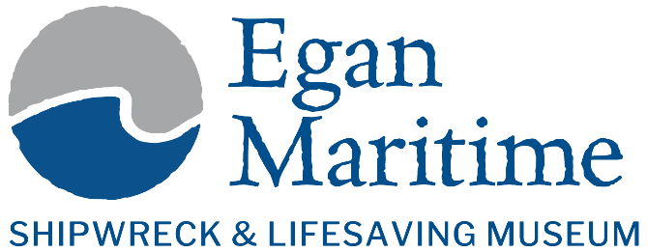
Commercial Photography Permit & Hold Harmless Agreement
Please complete this form and return it to egan@eganmaritime.org at least two weeks before your requested date.
Photographer/Company Name:
Contact Person:
Email:
Phone:
Date of Photography:
Time Requested:
Number of Participants:
Type of Photography (portrait, film, advertising, etc.):
Fee Schedule:
Small (1–10 people): $50
Large (11–35 people): $100
Additional fees may apply for larger productions or interior use.
Hold Harmless Agreement:
By signing this permit, the photographer/company agrees to assume full responsibility for all activities conducted on the Museum property.
The photographer further agrees to release, indemnify, and hold harmless the Shipwreck & Lifesaving Museum, its staff, board members, and affiliated organizations from any and all claims, damages, or liabilities arising out of their use of the property for photography purposes.
Photographer Signature:
Date:
Museum Representative:

